

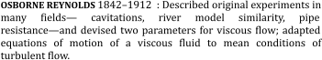





**Aim:** To find critical Reynolds number for a pipe flow.

**Apparatus Used:-** Flow Control Valve, Colored Jet injection, Collecting Tank etc.

# Theory: -

***Reynolds Number***

The Reynolds number is undoubtedly the most famous dimensionless parameter in fluid mechanics. It is named in honor of Osborne Reynolds 1842–1922, a British engineer who first demonstrated that this combination of variables could be used as a criterion to distinguish between laminar and turbulent flow. In most fluid flow problems there will be a

characteristic length 𝑙 and a velocity, *V*, as well as the fluid properties of densityρ, and

viscosity µ , which are relevant variables in the problem. Thus, with these variables the

Reynolds number arises naturally from the dimensional analysis. The Reynolds number is a measure of the ratio of the inertia force on an element of fluid to the viscous force on an element. When these two types of forces are important in a given problem, the Reynolds number will play an important role.

𝑅𝑒 = ρ𝑉𝑙

µ

At large Reynolds numbers, the inertial forces, which are proportional to the fluid density and the square of the fluid velocity, are large relative to the viscous forces, and thus the viscous forces cannot prevent the random and rapid fluctuations of the fluid. At *small* or *moderate* Reynolds numbers, however, the viscous forces are large enough to suppress these fluctuations and to keep the fluid “in line.” Thus the flow is *turbulent* in the first case and *laminar* in the second. The Reynolds number at which the flow becomes turbulent is called the **critical Reynolds number,** Recr. The value of the critical Reynolds number is different for different geometries and flow conditions. For internal flow in a circular pipe, the generally accepted value of the critical Reynolds number is Recr = 2300. It certainly is desirable to have precise values of Reynolds numbers for laminar, transitional, and turbulent flows, but this is not the case in practice. It turns out that the transition from laminar to turbulent flow also depends on the degree of disturbance of the flow by *surface roughness, pipe vibrations,* and *fluctuations in the flow.* Under most practical conditions, the flow in a circular pipe is laminar for Re ≤ 2300, turbulent for Re ≥ 4000 and transitional in between. That is,

**Laminar flow [**Re ≤ 2300]**:** A stable well-ordered state of fluid flow in which all pairs of adjacent *fluid particles* move alongside one another forming laminates. A flow that is not

laminar is either *turbulent* or *transitional* to turbulence, which occurs above a critical

*Reynolds number*

**Transitional flow[**2300 ≤ Re≤ 4000] : An unstable *vortical* fluid flow at a Reynolds number higher than a critical value that is large relative to 1, but is not sufficiently high that the flow has reached a fully *turbulent flow* state. Transitional flows often oscillate randomly between *laminar* and turbulent states.

**Turbulent flow [**Re ≥4000]: An unstable disordered state of *vortical* fluid flow that is inherently *unsteady* and that contains eddying motions over a wide range of sizes (or scales). Turbulent flows are always at *Reynolds numbers* above a critical value that is large relative to

1. Mixing is hugely enhanced, surface shear stresses are much higher, and head loss is greatly increased in turbulent flows as compared to corresponding *laminar flows.*

However, if the Reynolds number is very small 𝑅𝑒≪1 this is an indication that the viscous forces are dominant in the problem, and it may be possible to neglect the inertial effects; that is, the density of the fluid will not be an important variable. Flows at very small Reynolds numbers are commonly referred to as “creeping flows”

# Procedure: -

* 1. Fill up sufficient water in dye tank and put a small amount of potassium paramagnet in to water.
  2. Start water flow. Adjust the water flow to about 2 LPM. Start the pump & dye injection.
  3. Wait for same time. A steady line of dye will be observed. Adjust dye flow, if required.
  4. Slowly increases the water flow see that water level in supply tank remains constant. At particular flow rate, dye line will be disturbed note down this flow rate.
  5. Further increase the flow. The disturbances of dye line will go on increasing and at certain flow; the dye line diffuses over the entire cross section. Note down this flow.
  6. Slightly increase the flow and then slowly reduce the flow. Note the flow at which diffused dye tends to become steady, (beginning of transition zone while reducing velocity.)
  7. Further reduce the flow and note the flow at which dye line becomes Straight and steady.

# Observations:-

I.D of the pipe i.e characteristic liner dimension/length [D] =2 cm

Area of the Pipe𝐴 = π 2 π 2

−4 2

4 𝐷 = 4 0. 02 = 3. 14×10 𝑚

µ

−6 2

Kinematic Viscosity of fluid (Given at NTP condition)= ν = =0.805×10

ρ

𝑚

𝑠

# Observation Table



Sr.

No

1.

Time for 10cm

rise in water level (Sec.)

Discharg

e (

𝑚 )

3

Velocity

𝑚

𝑠

( )

𝑠

Reynolds

number

Flow Type

2.

3.

4.

5.

6.

7.

8.

**Sample Calculation**

Flow Velocity is calculated by using discharge Q

𝑉𝑜𝑙𝑢𝑚𝑒 𝑜𝑓 𝑤𝑎𝑡𝑒𝑟 𝑐𝑜𝑙𝑙𝑒𝑐𝑡𝑒𝑑

𝐷𝑖𝑠𝑐ℎ𝑎𝑟𝑔𝑒 [𝑄] =

𝑡𝑖𝑚𝑒 𝑓𝑜𝑟 10𝑐𝑚 𝑟𝑖𝑠𝑒 𝑜𝑓 𝑤𝑎𝑡𝑒𝑟 𝑙𝑒𝑣𝑒𝑙 𝑖𝑛 𝑡𝑎𝑛𝑘

3

and

𝑡

𝑠

𝑄 = 𝑎𝑟𝑒𝑎 𝑜𝑓 𝑡𝑎𝑛𝑘×0.10 𝑚

Velocity [V]= 𝐷𝑖𝑠𝑐ℎ𝑎𝑟𝑔𝑒 = 𝑄

𝑚

𝐴𝑟𝑒𝑎

𝐴 𝑠

𝑅𝑒𝑦𝑛𝑜𝑙𝑑 𝑛𝑢𝑚𝑏𝑒𝑟 [𝑅𝑒] = ρ𝑉𝐷

µ

𝑅𝑒𝑦𝑛𝑜𝑙𝑑 𝑛𝑢𝑚𝑏𝑒𝑟 [𝑅𝑒] =  𝑉𝐷

ν

𝑅𝑒𝑦𝑛𝑜𝑙𝑑 𝑛𝑢𝑚𝑏𝑒𝑟 [𝑅𝑒] =  0.02×𝑉

−6

0.805×10

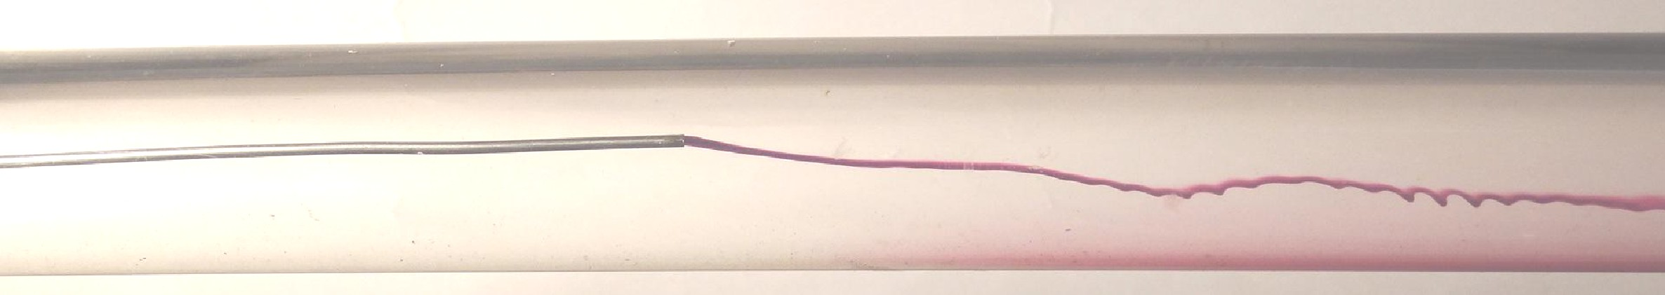𝑅𝑒𝑦𝑛𝑜𝑙𝑑 𝑛𝑢𝑚𝑏𝑒𝑟 [𝑅𝑒] = 𝑉×24844. 7

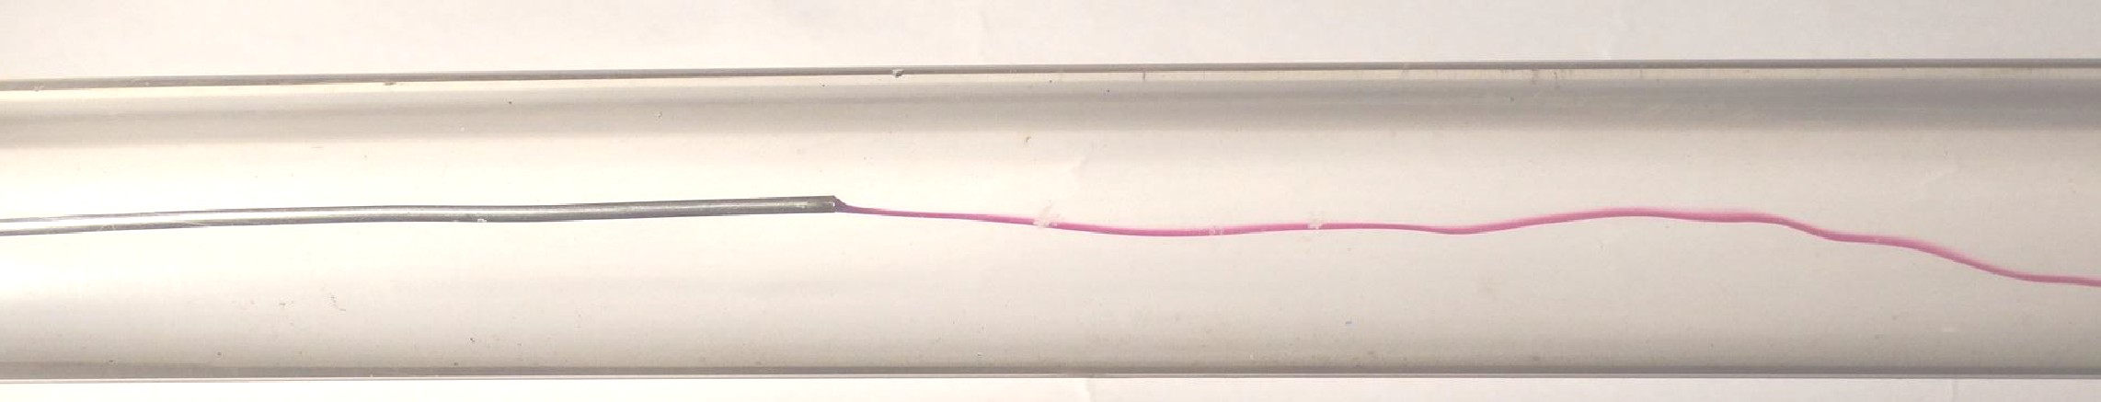

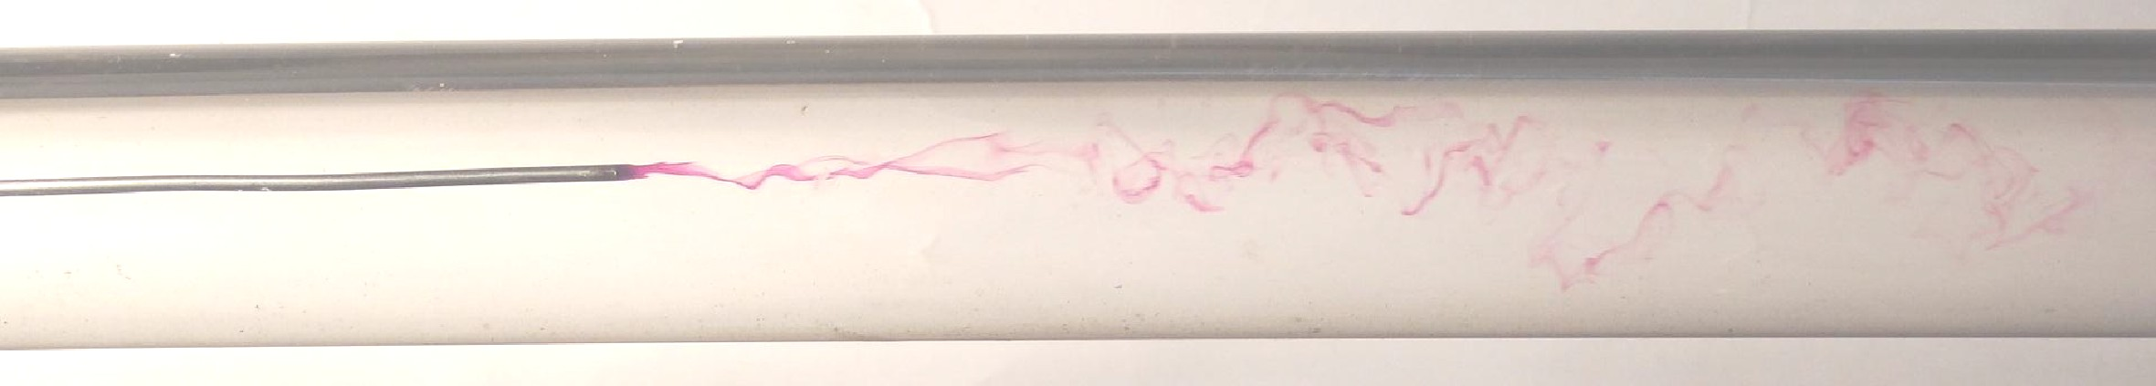

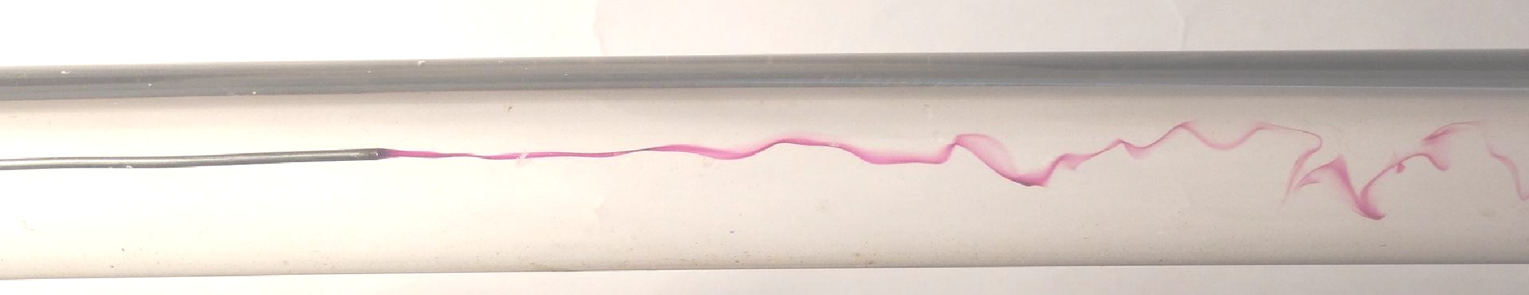Figure: Sequence of dye traces introduced in a tube with increasing Reynolds number (top to bottom).









**Conclusion**: Students should conclude the experiment in two to three lines

